In The Name of God

Mohammad Mashreghi – SID =810199492 - LN = 89

1)

A)



|  |  |  |
| --- | --- | --- |
| 0.5 | 0.1000000000000000 | 0 |
| 0.08333333 | 0.0001010101010101 | 1 |
| 0.03333333 | 0.0000100010001000 | 2 |
| 0.0178571428 | 0.0000010010010010 | 3 |
| 0.01111111111 | 0.0000001011011000 | 4 |
| 0.00757575757575 | 0.0000000111110000 | 5 |
| 0.005494505494 | 0.0000000101101000 | 6 |
| 0.004166666666 | 0.0000000100010001 | 7 |

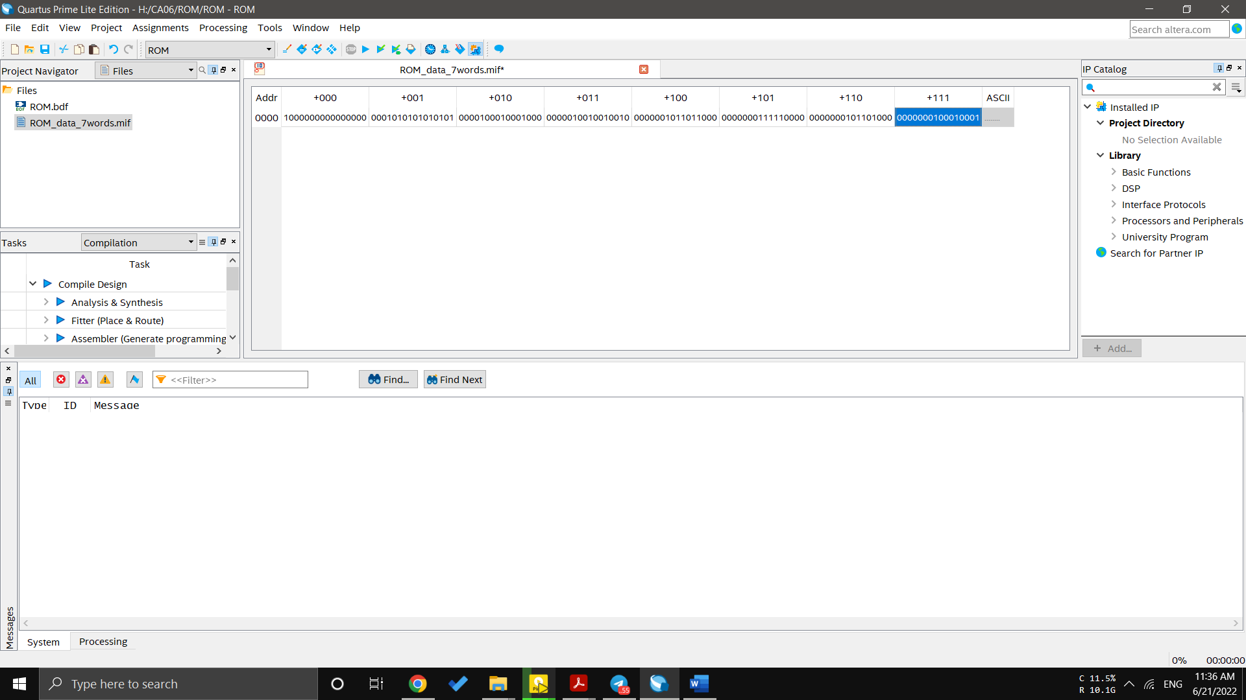

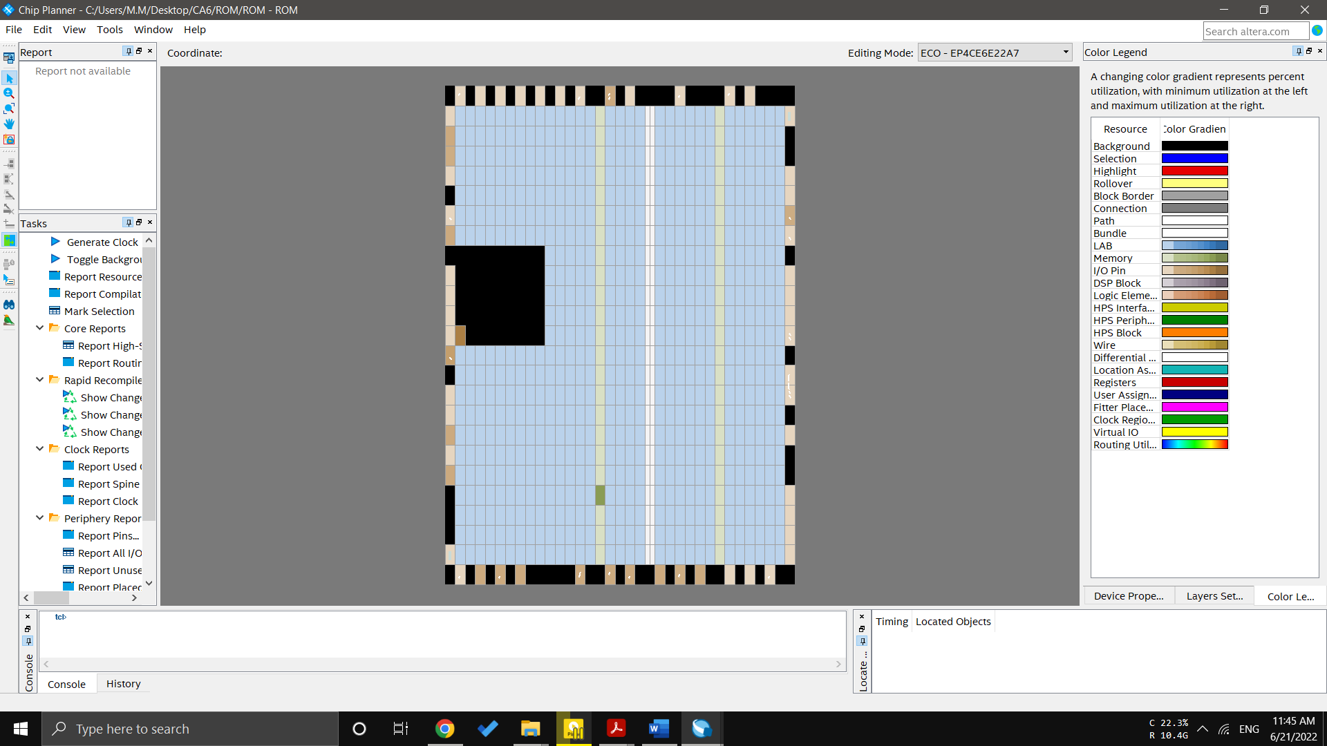

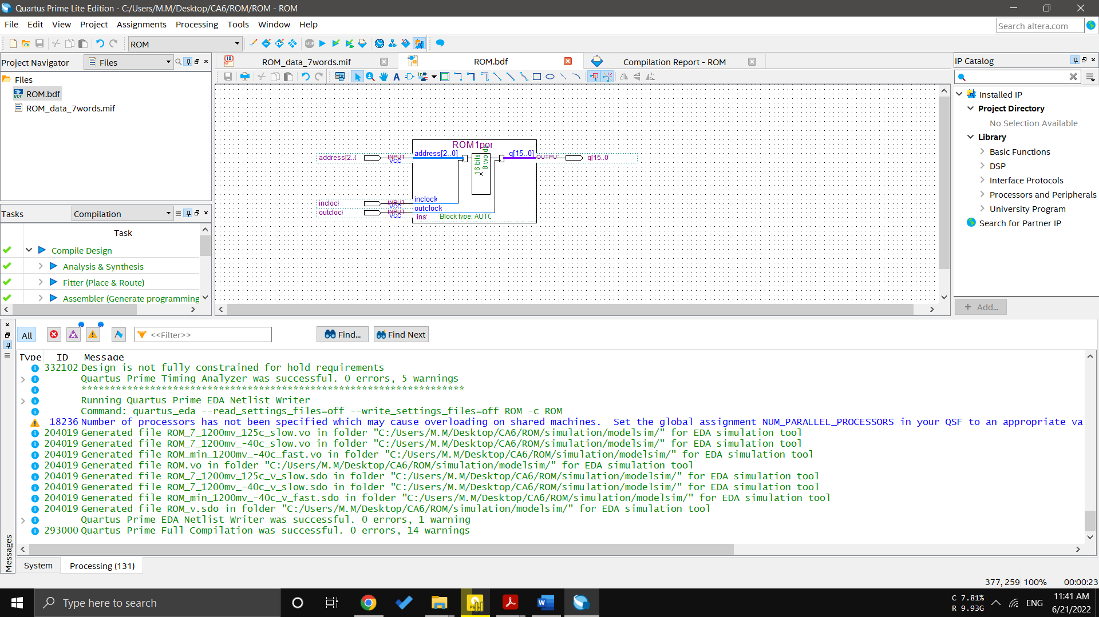

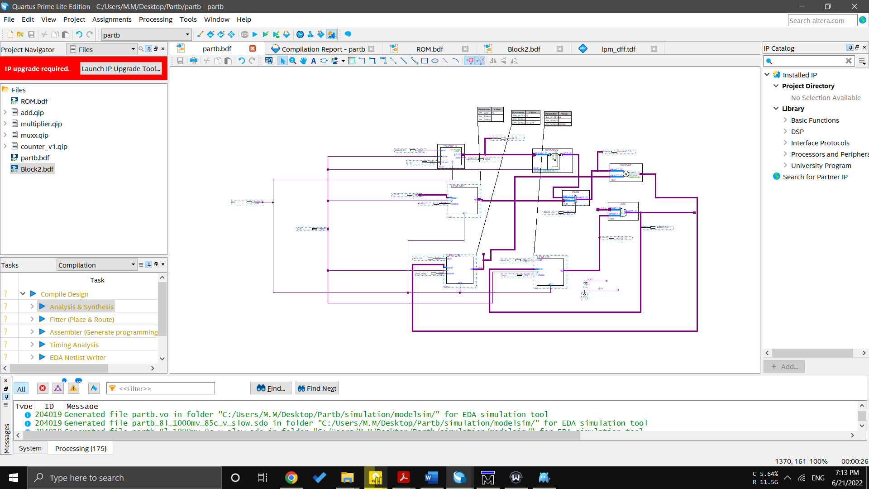b)

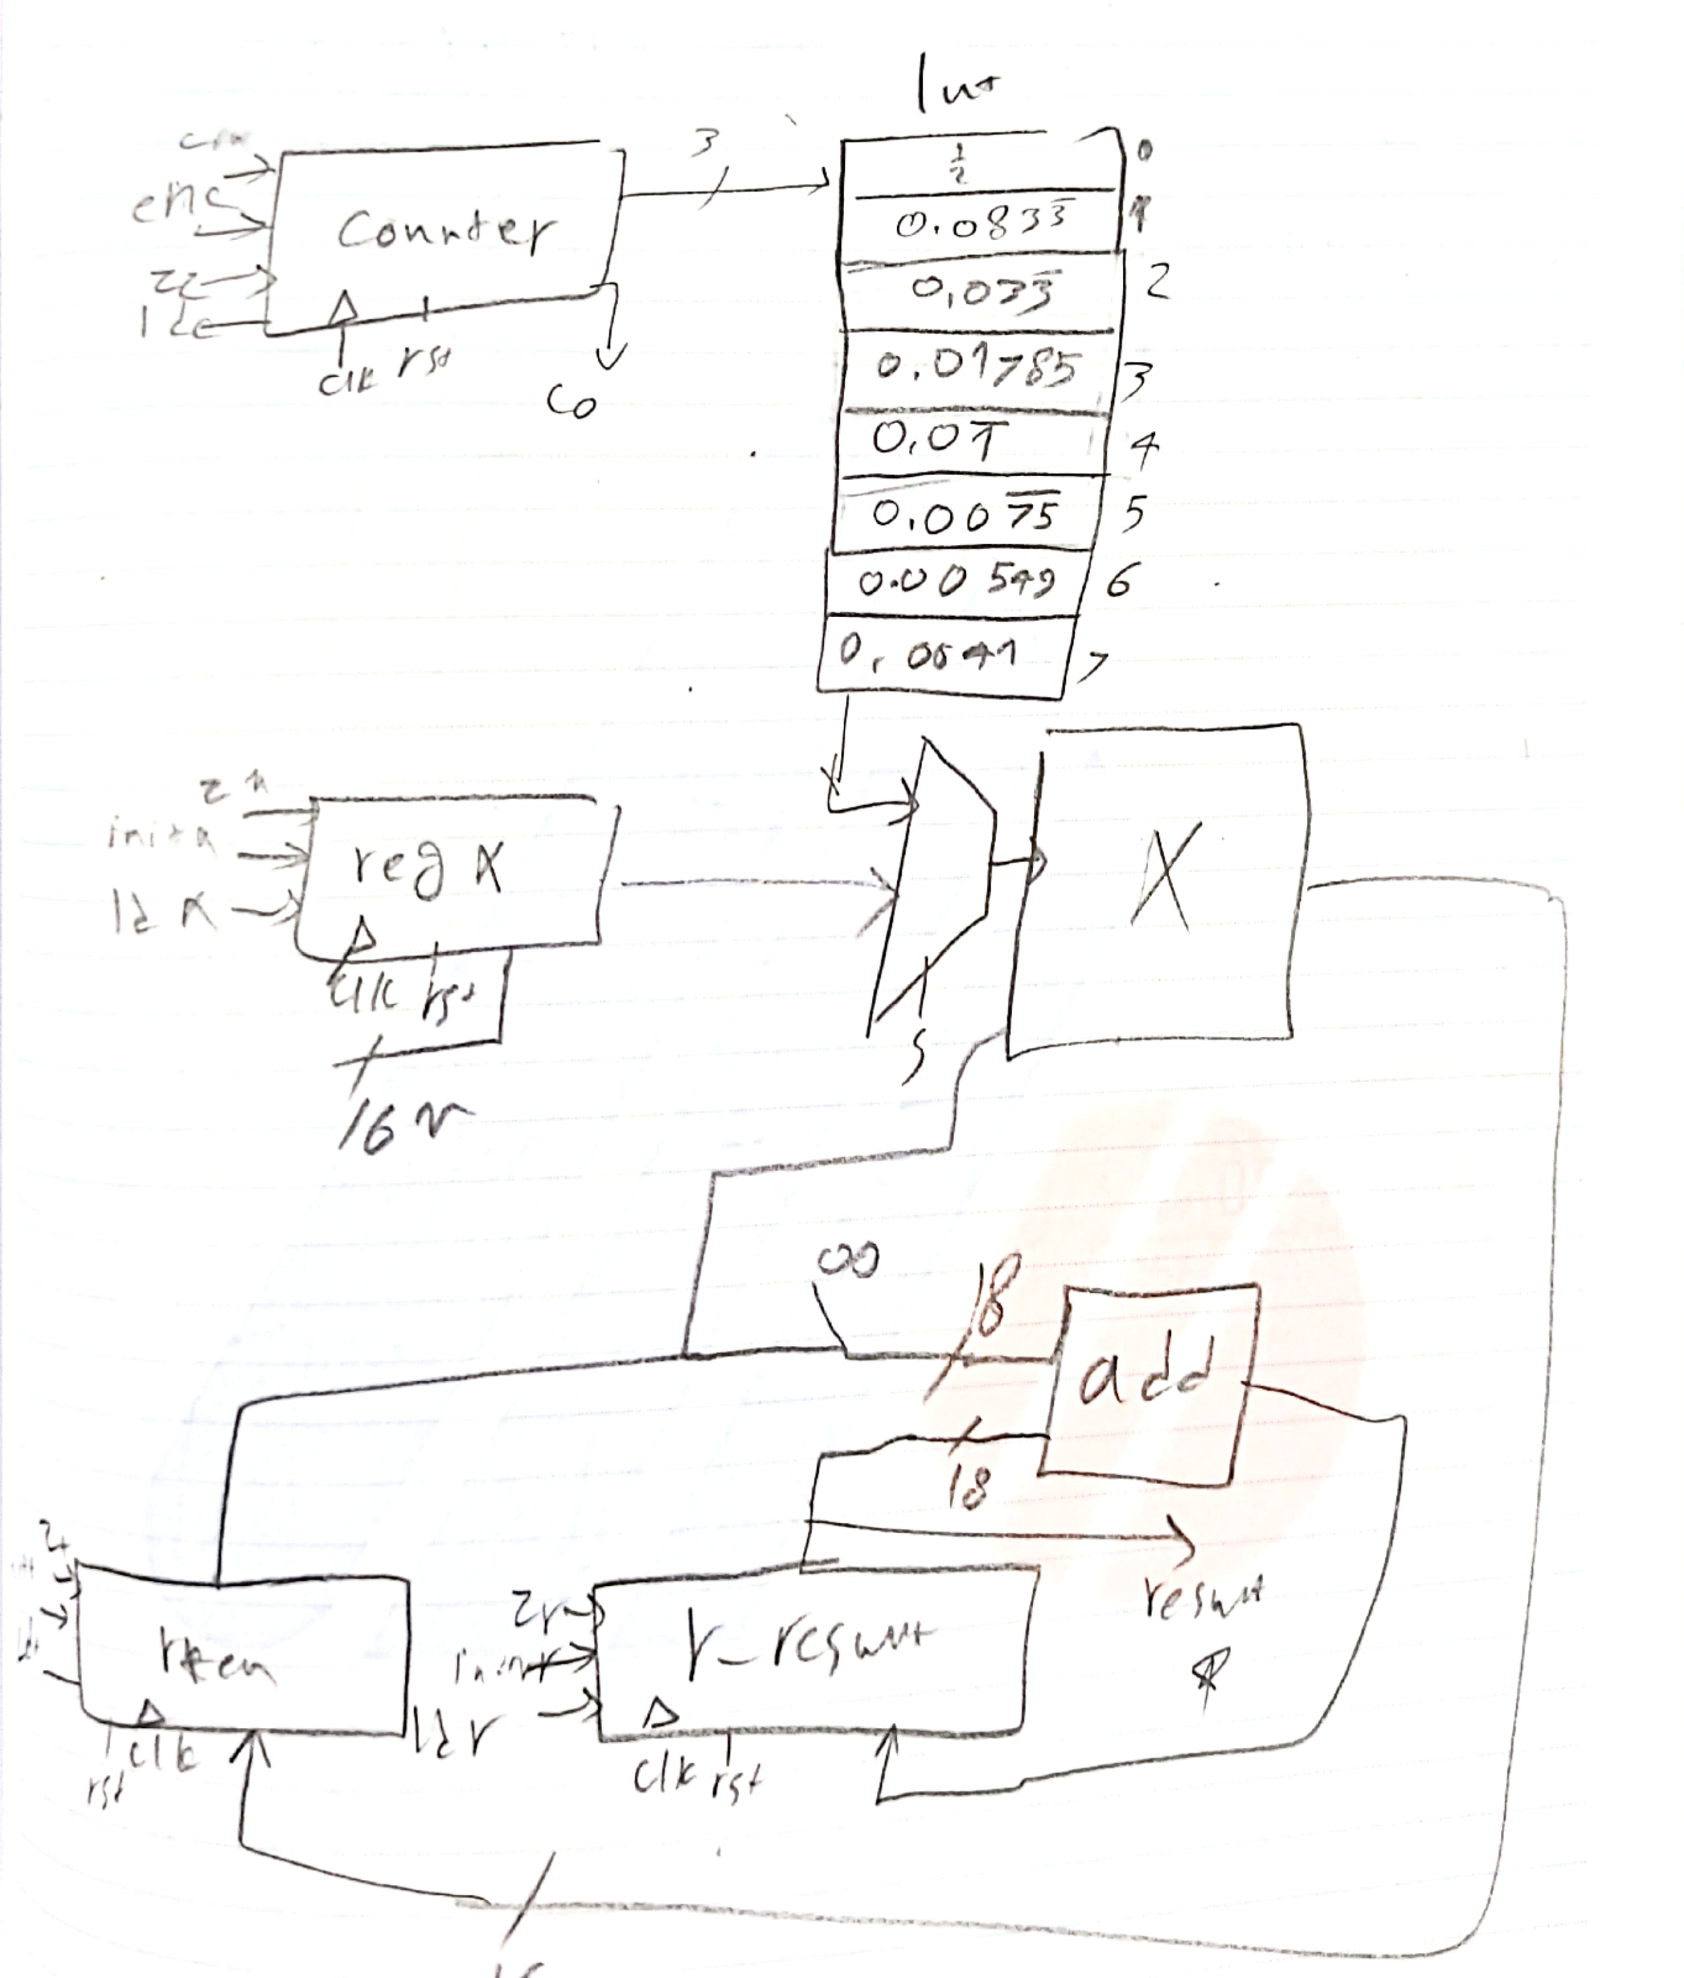

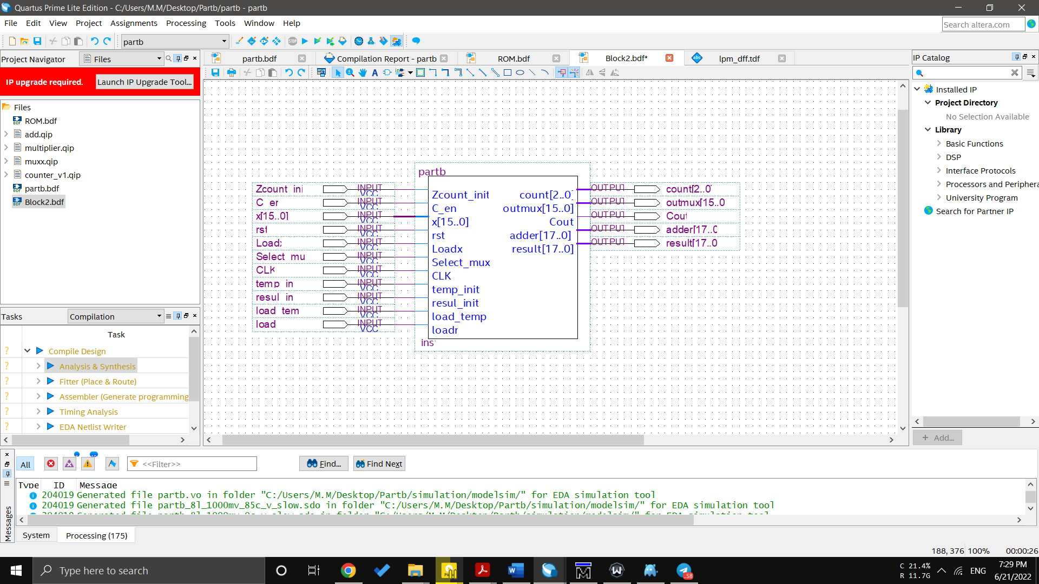

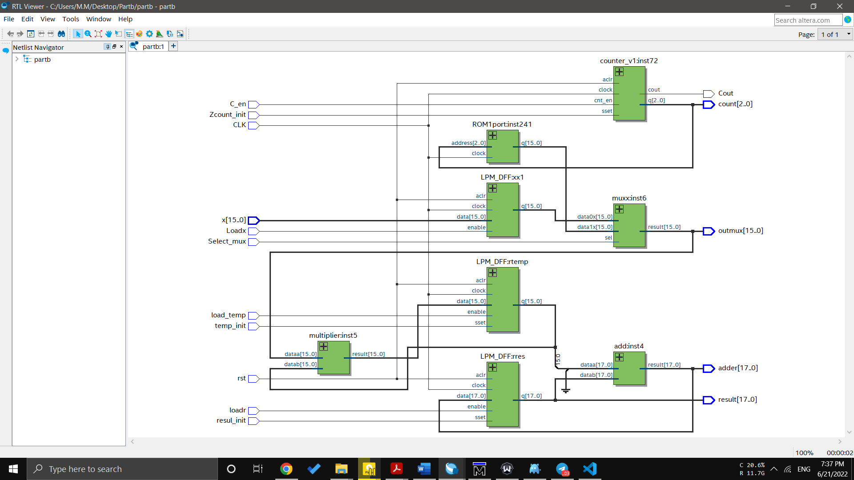

c)

state machine diagram:



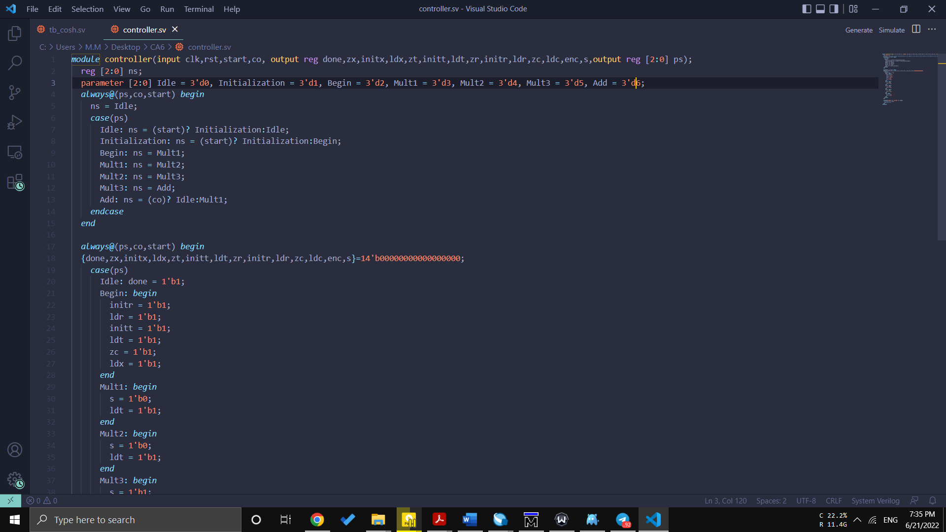

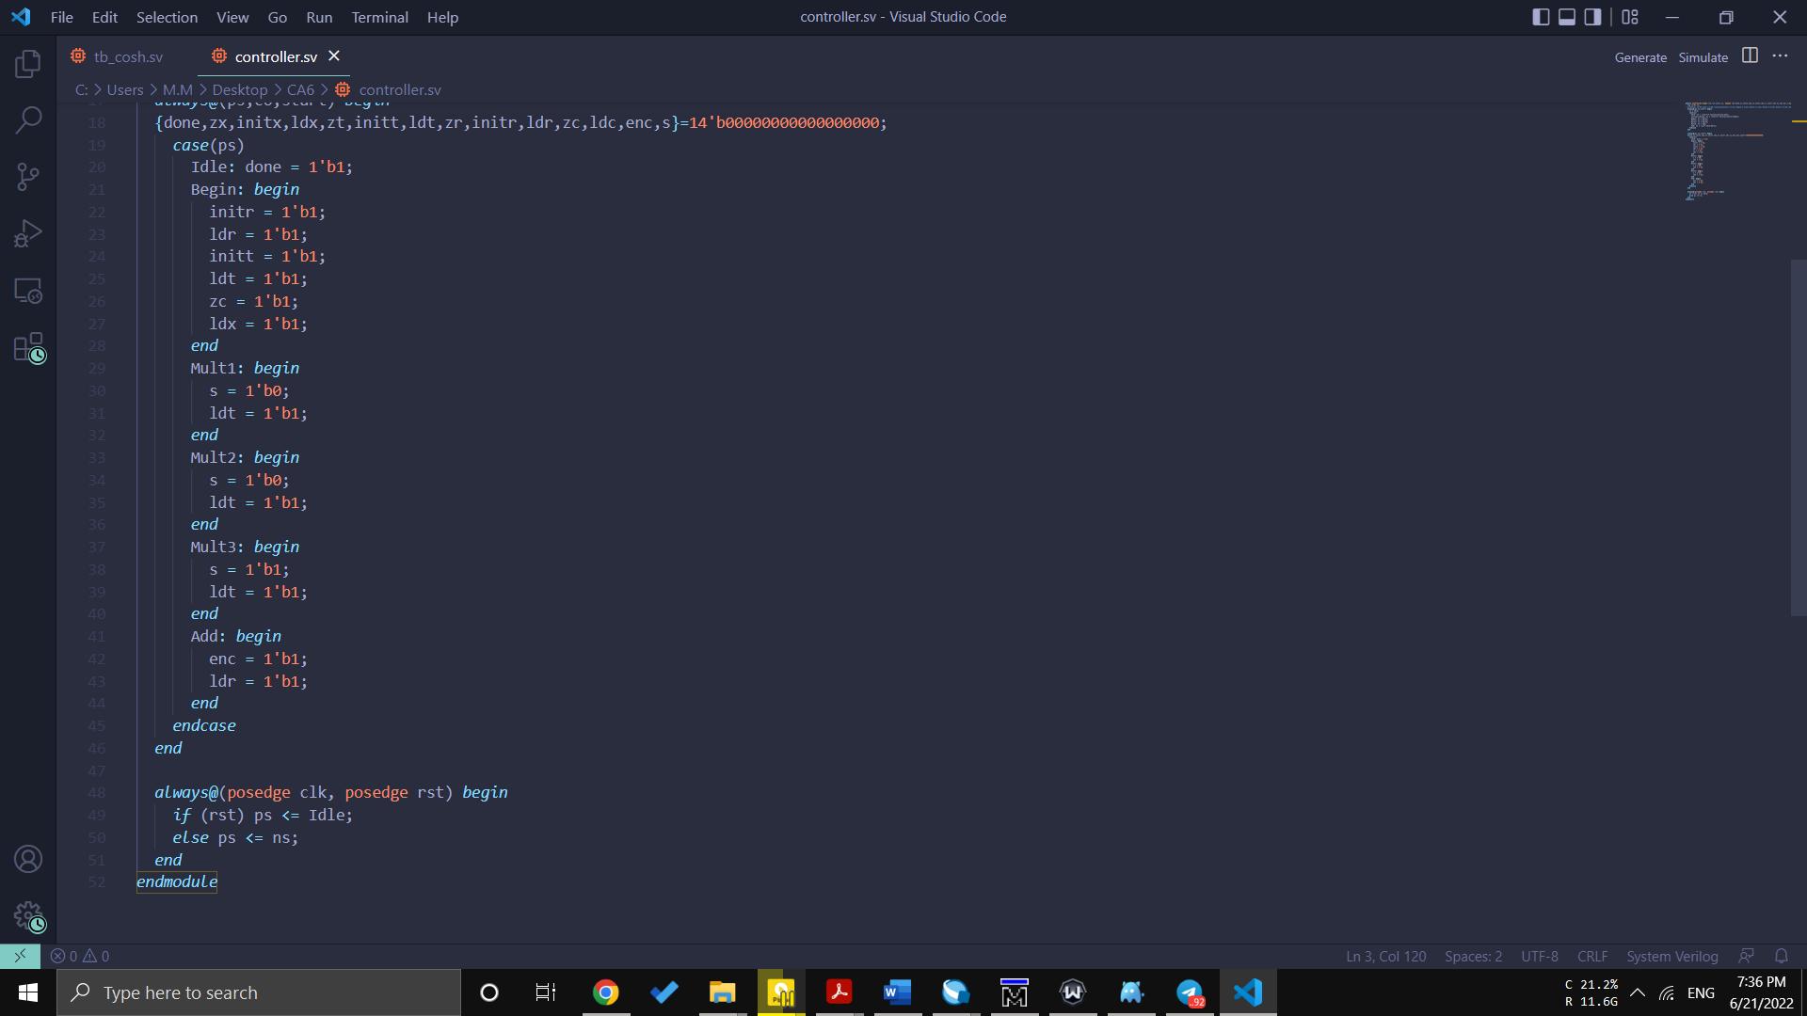

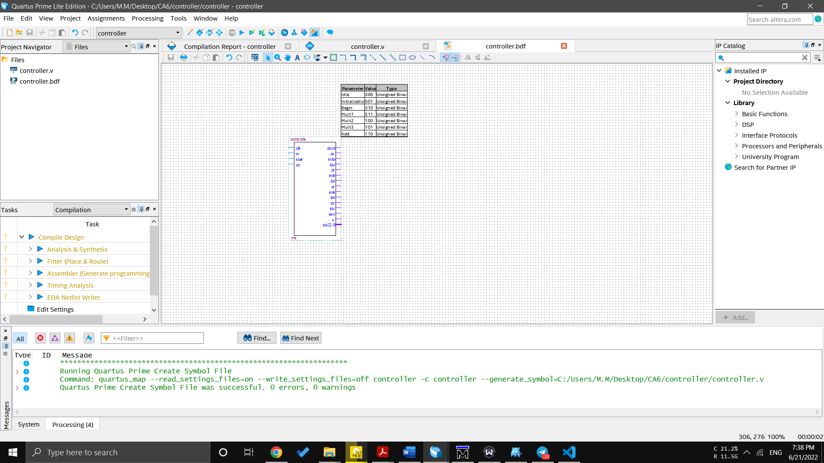

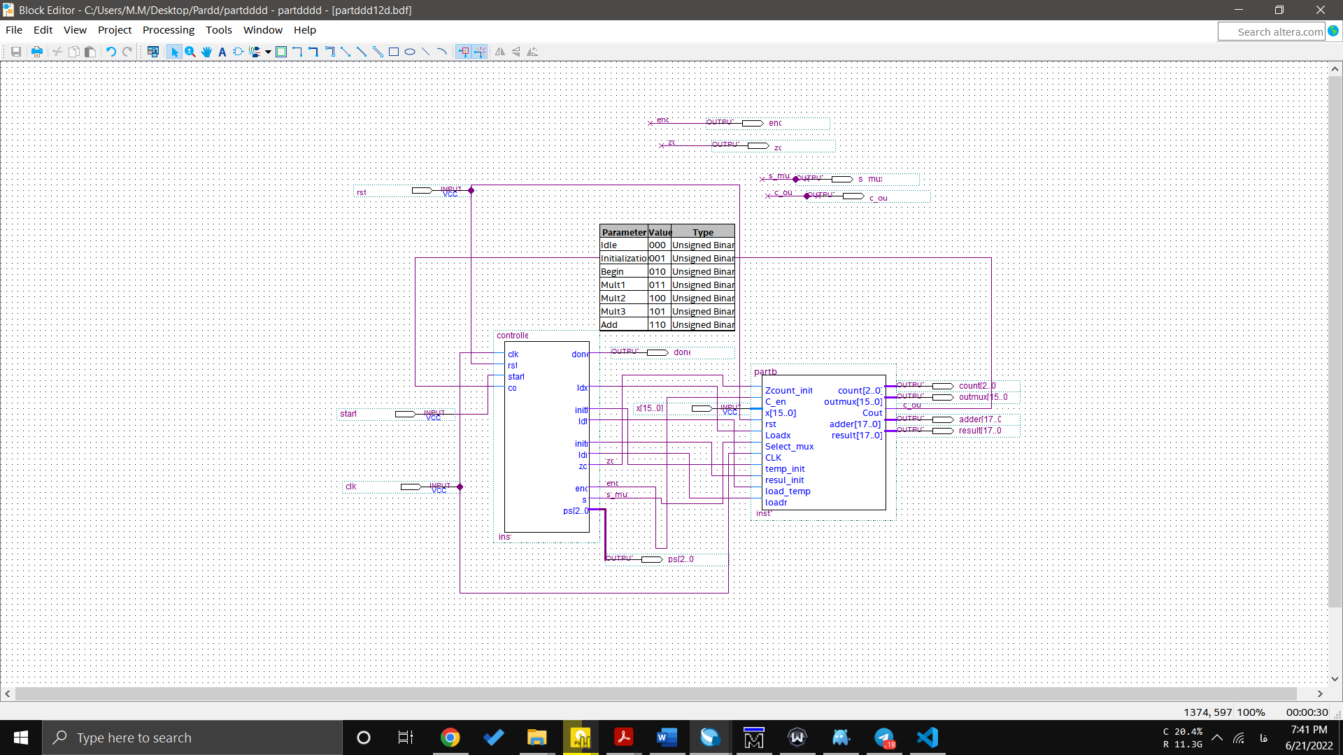

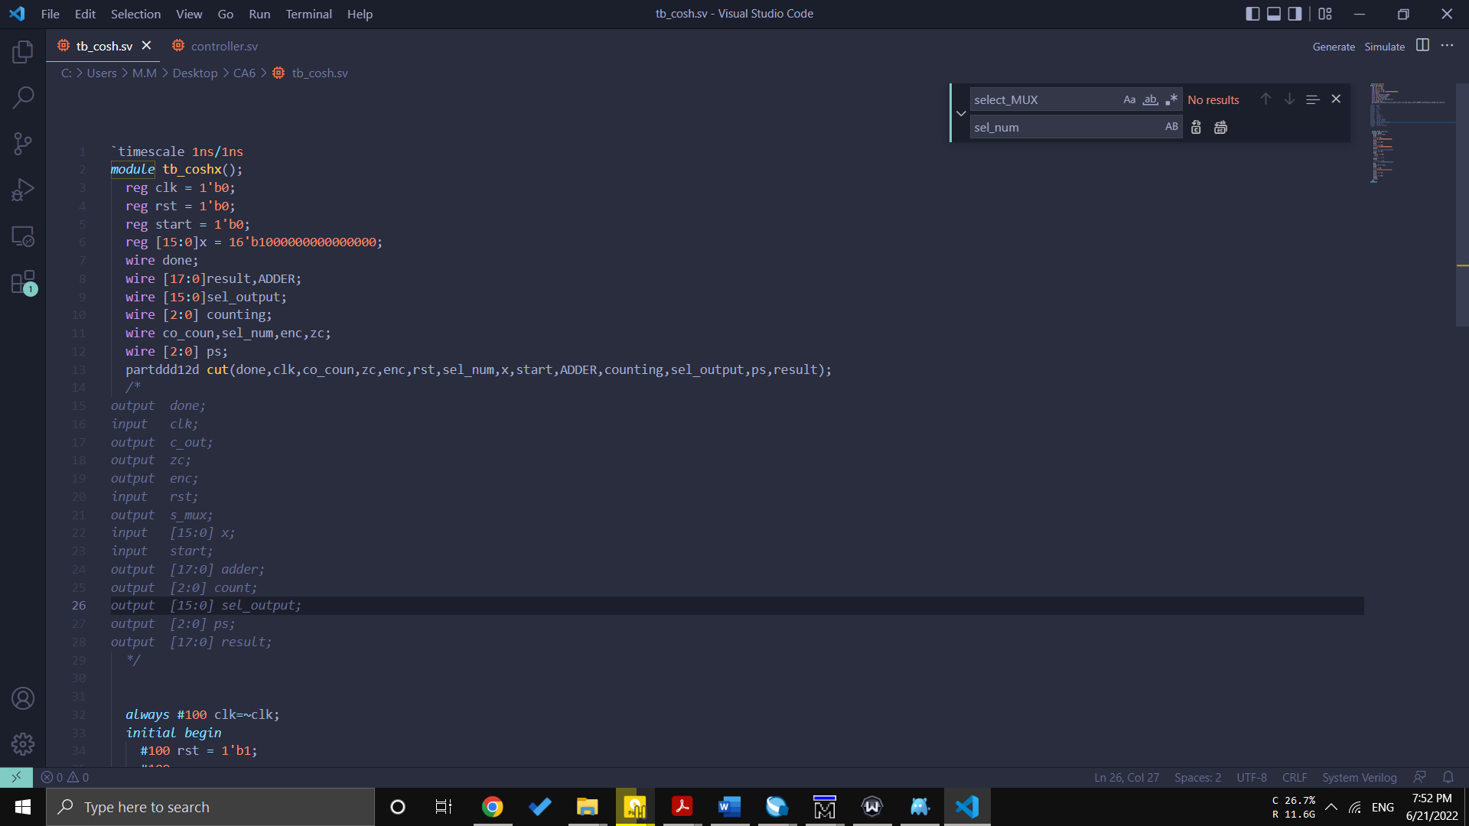Testbench:

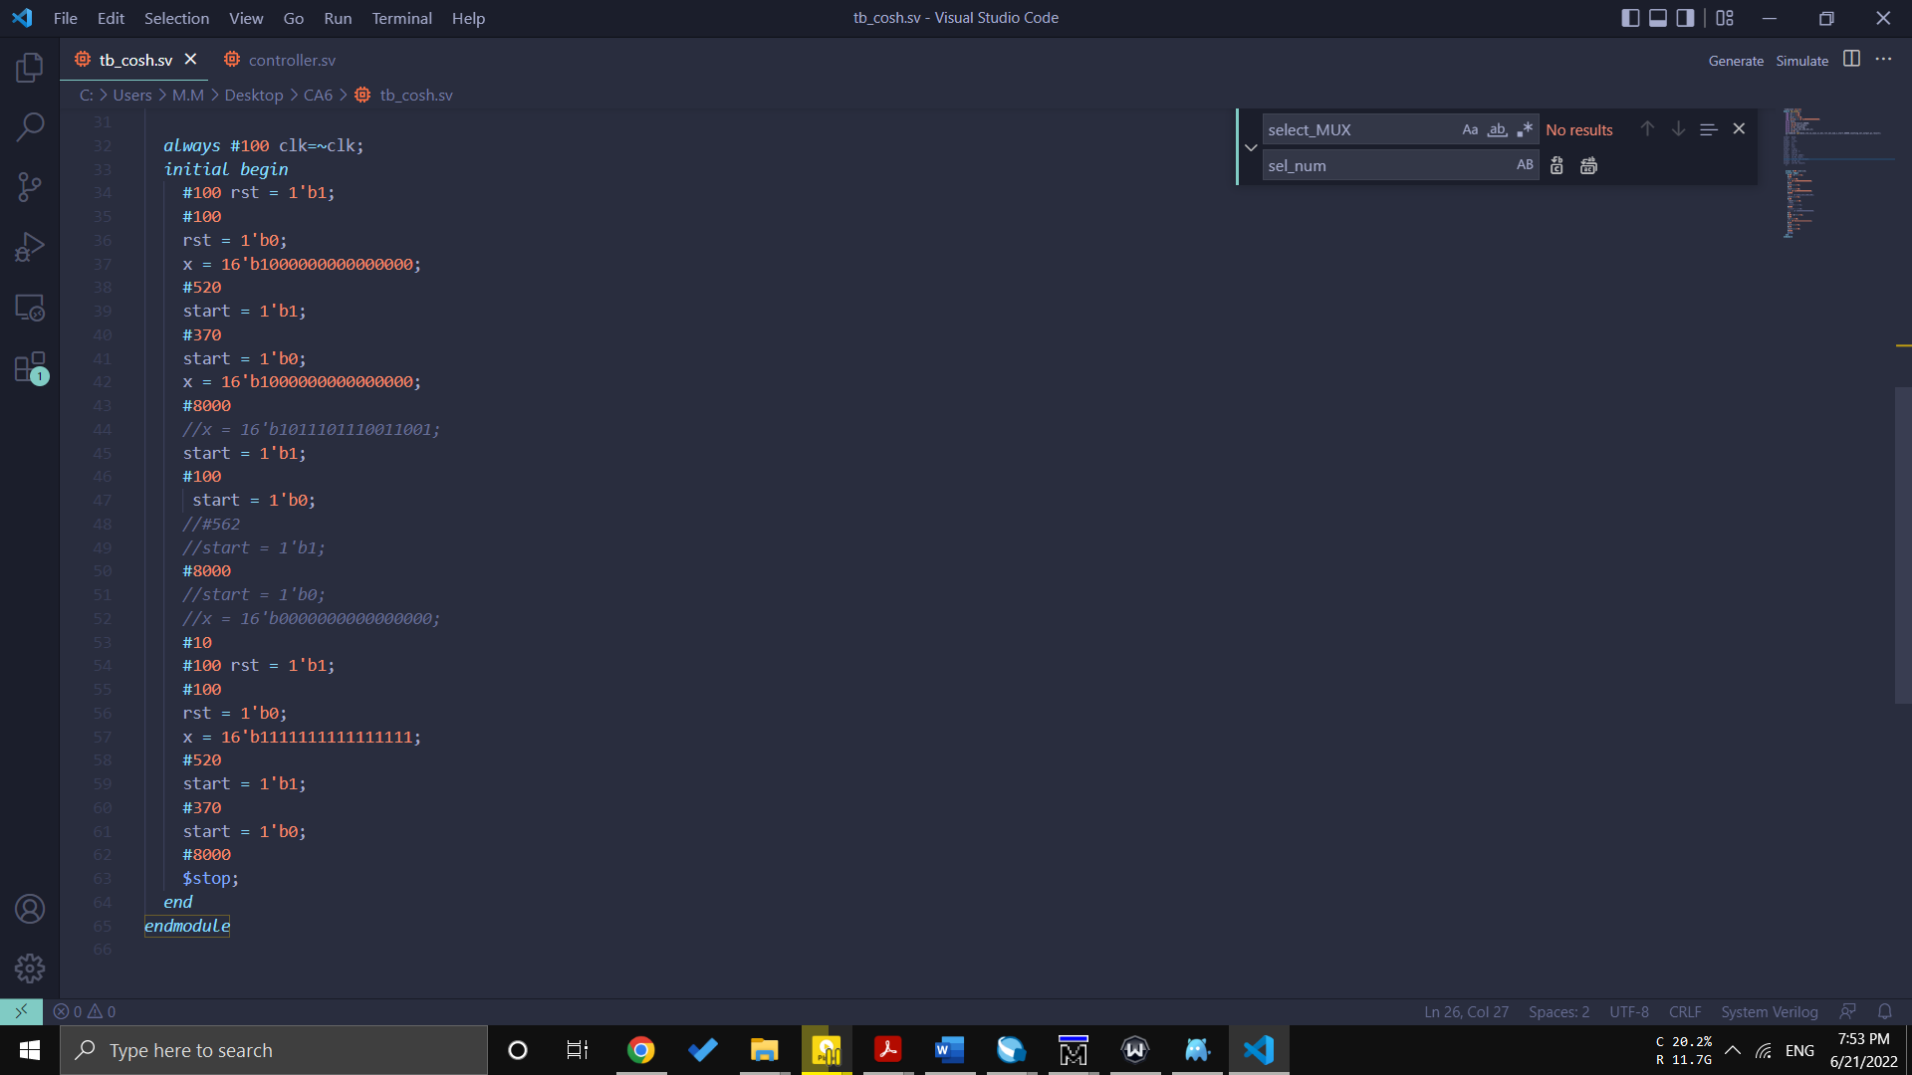

test 1:

X=1

Cosh(1)=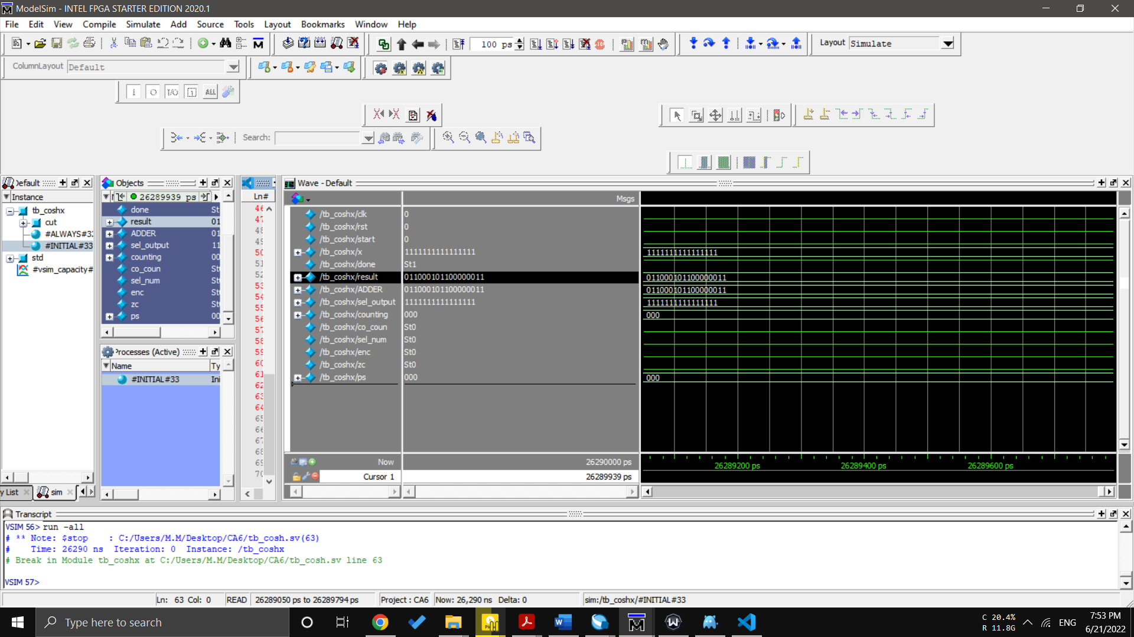1.54308063482

Result of devise : 1.5430145263671875

test 2:

X=0.5

Cosh(0.5)=1.1276259

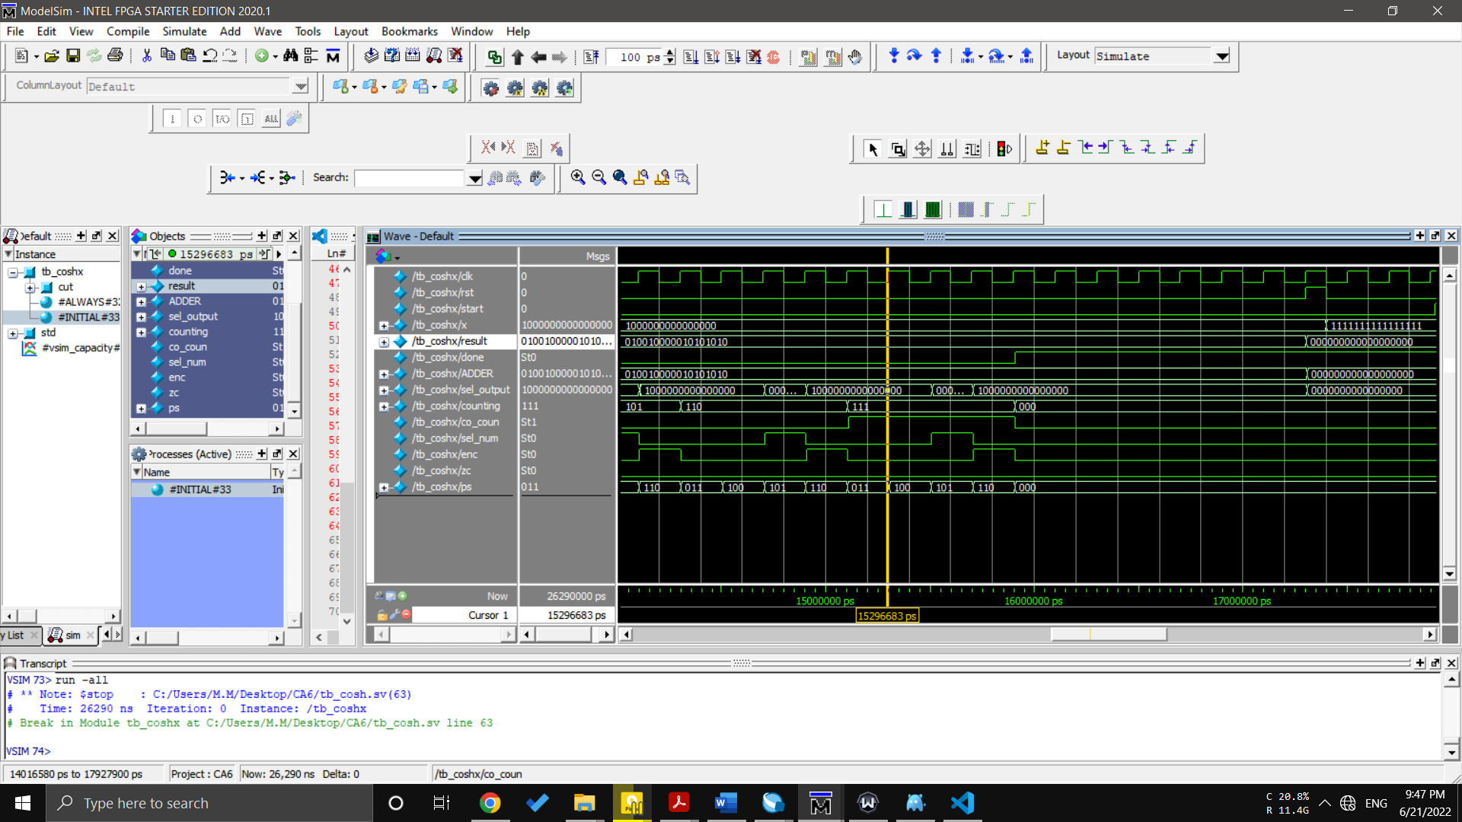Result= 1.12744140625

test 3:

X=0.8

Cosh(0.8)= 1.3374349463

Result= 1.33740234375

